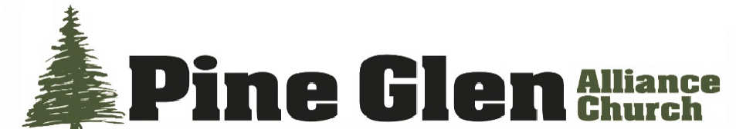
Quarterly Report of the Treasurer
April 23, 2026
Dear Pine Glen Alliance Church Family,
Pine Glen Alliance Church began 2026 with total current assets of $303,033.01. This is an increase of $13,972.58 over the beginning of 2025. The approved budget for this year is $221,920, an increase of $8,618 over the previous year.
Total income for the first quarter was $42,464. Total expenses for the same period were $57,455.
To cover all budgeted expenses requires weekly giving of $4,268. As of March 31, weekly giving averaged $3,539.
A snow storm on January 25th resulted in cancelling church services; eliminating one week of expected offerings.
First quarter expenses were somewhat higher than usual. The cost for propane to heat the church during the extremely cold weather was $3,675.01. Electricity cost $6,622.09. After having switched to a third-party electricity provider in early 2024, to get a better rate per KW/hr., we found it was not a beneficial change. Therefore, we recently switched again to a fixed rate provider that has guaranteed not to raise the rate for five years.
The cost of a new sound board and related technology updates for the church was $3,380.97. Miscellaneous electrical and plumbing services totaled $1,048.29. In addition, we made our annual missionary donation of $2,000 each to the Sandlers and Straws.
In October, we invested $55,000 of our cash reserve in 5-month CDs at Kish Bank at an annual interest rate of 3.9 percent. On March 2, 2026, the bank reduced in annual interest to 3.65 percent. It was quickly restored back to 3.8 percent.
In May, we anticipate replacing the current copy machine in the Main Office. This would reduce the monthly lease cost by $30.34 and the cost of printing black and white copies from $0.0103 per page to $0.0050 per page; less than ½ the annual cost. Additional cost reduction efforts are being explored.
Historically, the church conducted an annual audit of the income side of our finances. However, there has never been a mechanism for auditing the outgoing (cost) side. This has been addressed by the creation of a monthly Reconciliation Report that enables us to track the Beginning Register Balance, Checks and Payments Cleared, Deposits and Other Credits Cleared, the Summary of Uncleared and Cleared Transactions and Ending Register Balance. When compared with the monthly bank statements and internal Balance Sheets, this mechanism will facilitate complete auditing of all church finances.
Jeannie McCartle is solely credited for the creation of this Reconciliation Report.
Respectfully submitted:
Dennis H. Walters, Treasurer

